Apparel Personalization on medline.com
New Logo Design Request

On medline.com, through the Apparel Personalization link a User will be able to create a Logo Design Request. The Design being requested will always be for the active Sold-To Account that the User is signed into.
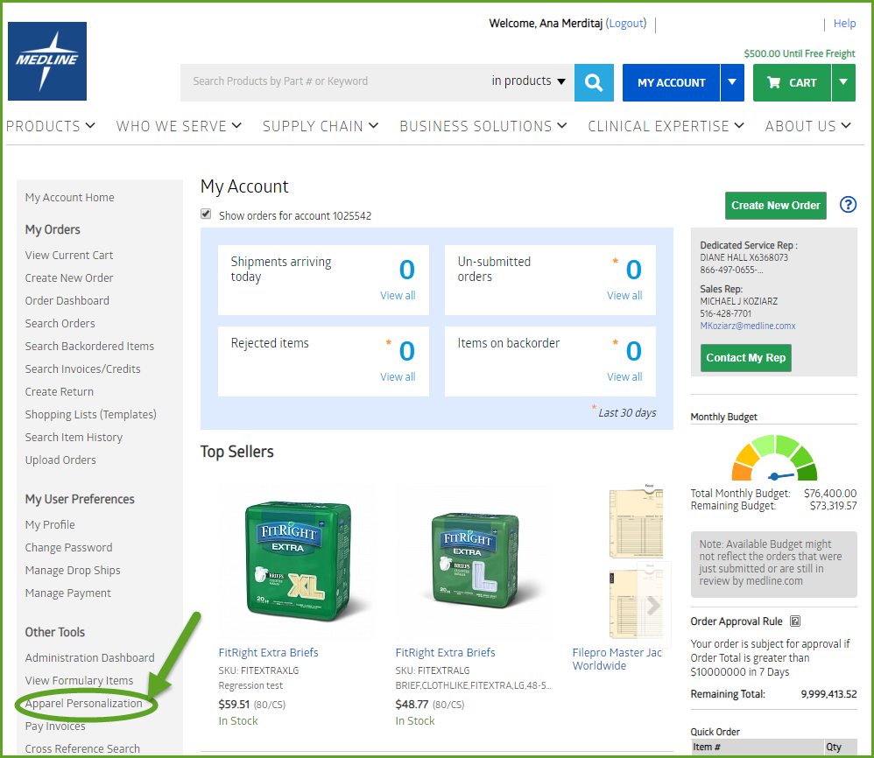
When the User clicks into the apparel personalization link, they will see the new Logo design request page. This page will consist of the embroidery digitization form. Through the form the User can request three different services:
- A Set Up for a brand new Logo
- Modification to an existing Logo
- Color change to an existing Logo
Each Service Request will have a Cost associated with it. The Cost of each Request Type is tied to a SKU Number and could be changed by the sales representative for any give Sold-To Account. The sales reps should follow the same process as they do for any other item on medline.com when it comes to changing prices
Service and SKU relationship
Request Type | SKU | Recommend Sales Price
Embroidery Logo set up | MDTEMBSETUP | $50.00
Embroidery Logo modification | MDTEMBMODIFY | $25.00
Embroidery Logo color change | MDTEMBCOLORCH | $10.00
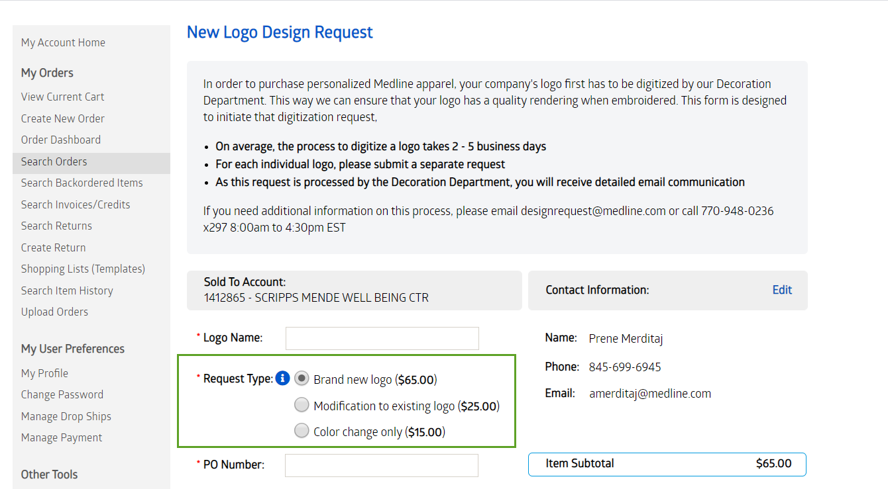

If the User chooses to modify an existing Logo or if they choose to do a Color Change to an existing Logo, a new field will display asking for the existing Logo Id. The Logo id will be validated against the Logos stored in the SAP table “ZVELOGO”.

- If the Account and Logo Id combination are not found, then an error message will display for the User. The User will need to have a valid Logo Id to be able to submit the Request Form.
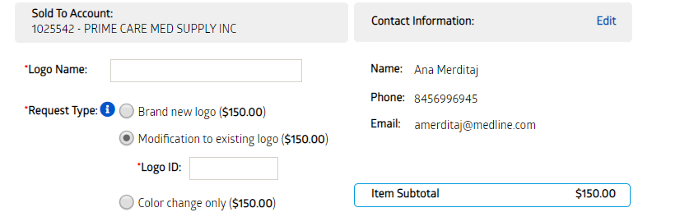
The next set of data which the User will need to enter is the Order Data for processing the Order for the Request Type they have selected.
- Every User will have to enter the PO Number for their Order. This is a standard required field on medline.com for any Order.

- The payment type for most Users will include Pay by PO/Invoice or Credit card. However, not all Users will have both options available.

  - If the User is only allowed to place Credit Card Orders on medline.com, then the Credit Card option will be the only option they have and vice versa for the PO Number.

- For Credit Cards, we will not be allowing them to enter the Credit Card Information as we will be sending to the Decoration Team all of the information that the User filled out through an email. Credit Card information is not allowed to be passed through email.

  - If the User selects Credit Card option, the Decoration Team will reach out to them and get the Credit Card information over the phone before the service is performed.
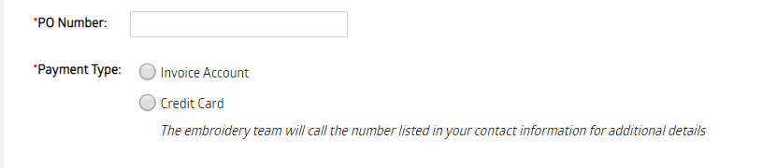

The Image Upload will be required for all new Logo Setups but it will be optional for Modification to existing Logo or a Color Change to the existing Logo.
File Types accepted and the minimum and maximum size allowed will be stated for the User. The User will be able to see the Image they uploaded, this way they can be sure they uploaded the correct Image.
Prior to Image Upload: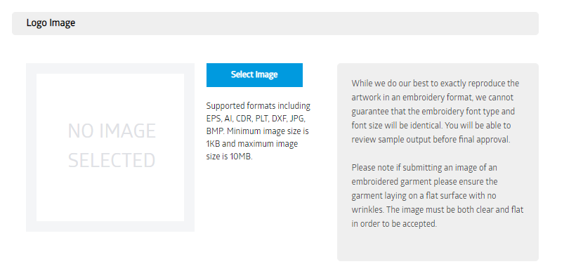After Image Upload: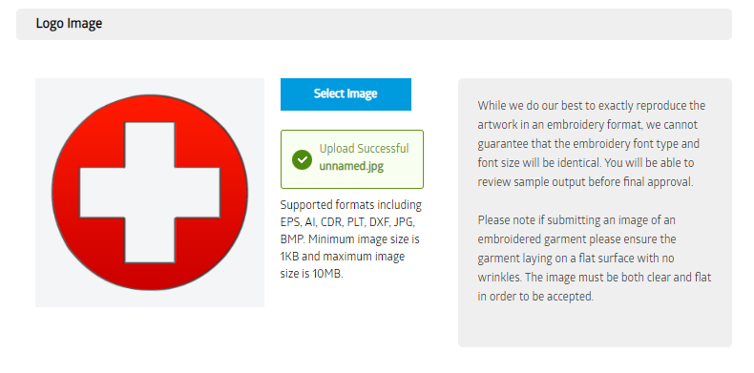
The next section which the User has to fill out, regardless of the Service Request Type selected, is the Items they plan to put the Logo on.
- If they know the Item Numbers they plan to put the Logo on, then they can enter the Items, if they don’t know the Item Numbers then they will at least have the “Select the Types of Items” they would like to have the Logo on such as Scrubs, Lab Coats, Polos, etc.
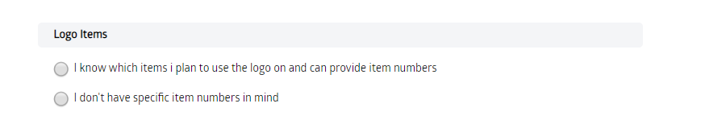
- If they know the Items they plan to put the Logo on, it will look like this when they select that option:
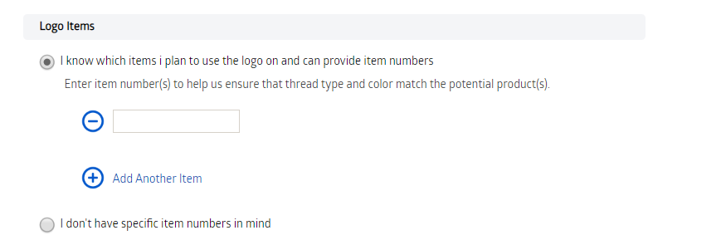

- If they don’t know the Items they plan to put the Logo on, it will look like this:

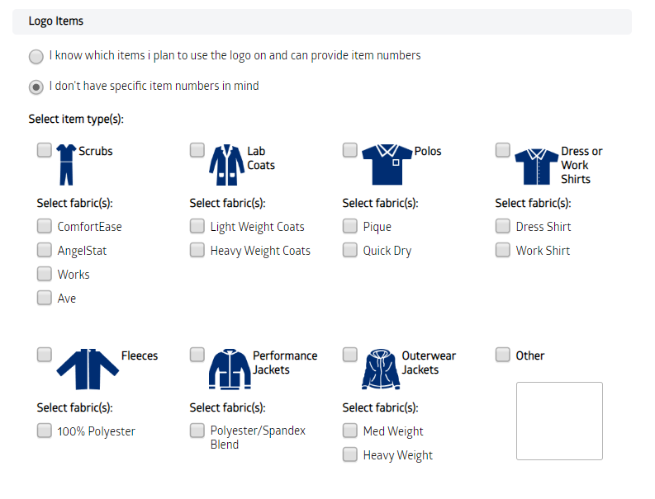
Just like with the Logo Items, the question “If the User wants to create an Alternate Logo with a Contrasting Color”, will be required regardless of the Service Request Type they select.

The last section the User will have is the Notes Section which is an optional field they can choose to add Comments further explaining their Request if they want to.
